- The increase in UK government bond yields since the start of the Iran war has been greater than in most other advanced economies. Markets clearly perceive the UK has a bigger inflation problem and that tighter monetary policy will be needed to limit second-round effects from the energy shock, while political uncertainty has added to pressures at the long end.
- Assuming our baseline forecast that oil and gas prices will drop sharply in H2 plays out, we expect the Bank of England to keep rates on hold. As markets adjust, this should pull down the front end of the curve. But it will likely take time, and the risks are skewed towards modest rate hikes that keep yields higher for longer.
- Even if short-end pressures fade, the long end is likely to remain elevated, causing the curve to steepen. Term premia could rise further because fiscal slippage looks more likely, either via Prime Minister Keir Starmer’s attempts to regain popularity, or more likely from a successor implementing more costly left-wing economic policies. If Starmer sets out a timetable to stand down, the uncertainty premium will persist.
- We estimate the tightening in financial conditions will knock 0.2ppts off the level of GDP by the end of next year and 0.5ppts off business investment. It will also damage mortgage affordability, and borrowers refinancing five-year fixes this year will face higher mortgage rates – up at least 300bps.
Since the start of the US-Israel war with Iran, government bond yields have risen across the world as markets digest the inflationary consequences of the energy shock. The increase in UK yields has been much larger than elsewhere. At market close on May 11, the 10-year gilt yield was 71bps above pre-conflict levels; in most other advanced economies, the increase has been around 40bp (Chart 1).
Chart 1: The increase in 10-year government bond yields has been much larger in the UK than elsewhere
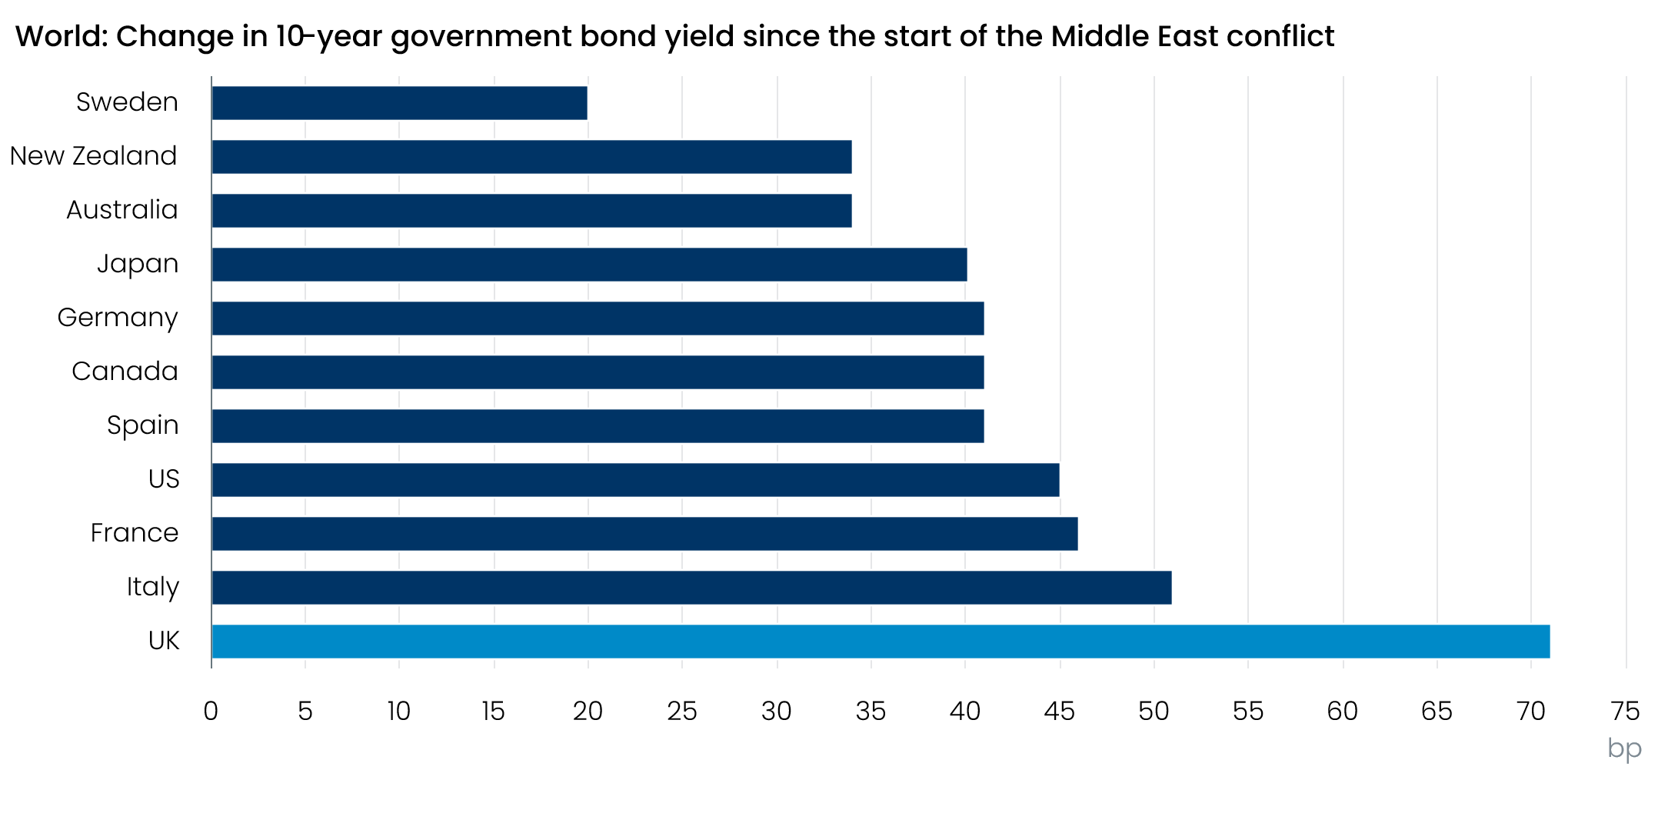
Sources: Oxford Economics, Haver Analytics

Expectations of higher short-term interest rates explain most of the movement at the longer end
The shorter end of the UK yield curve has risen by roughly 10bps more than the longer end (Chart 2). That developments at the shorter end have been key is consistent with changes in market expectations for Bank Rate. Before the conflict began, markets were pricing two 25bp rate cuts by the end of this year. Now, markets fully price two 25bp hikes this year, with a further hike priced for the first half of 2027 (Chart 3).
Chart 2: The yield curve has flattened since the start of the conflict
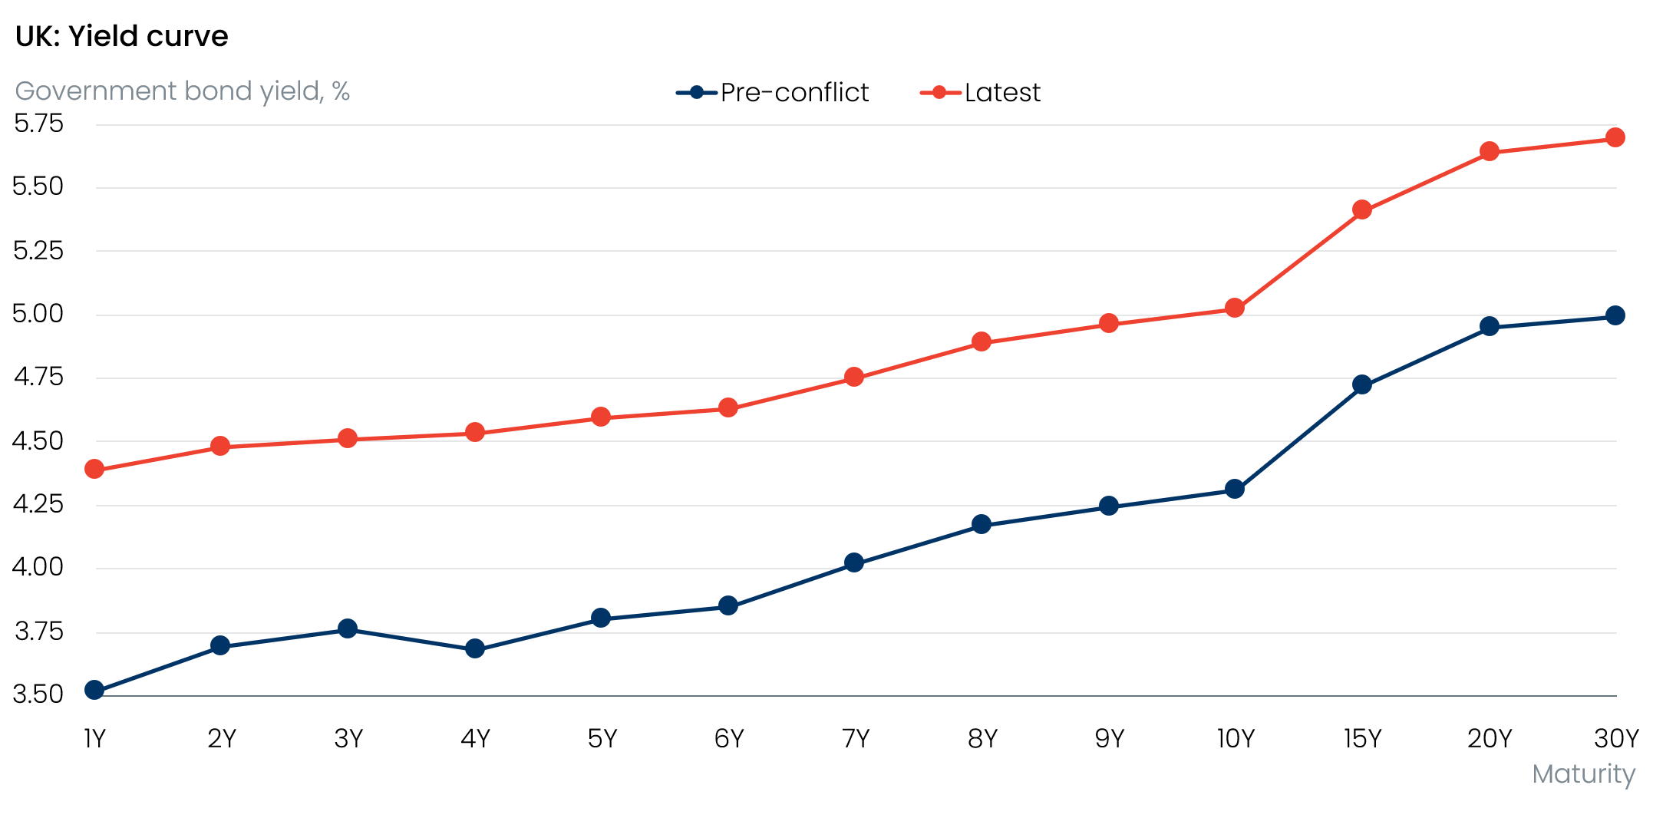
Source: Haver Analytics
Chart 3: Markets now price three 25bp rate hikes over the coming year
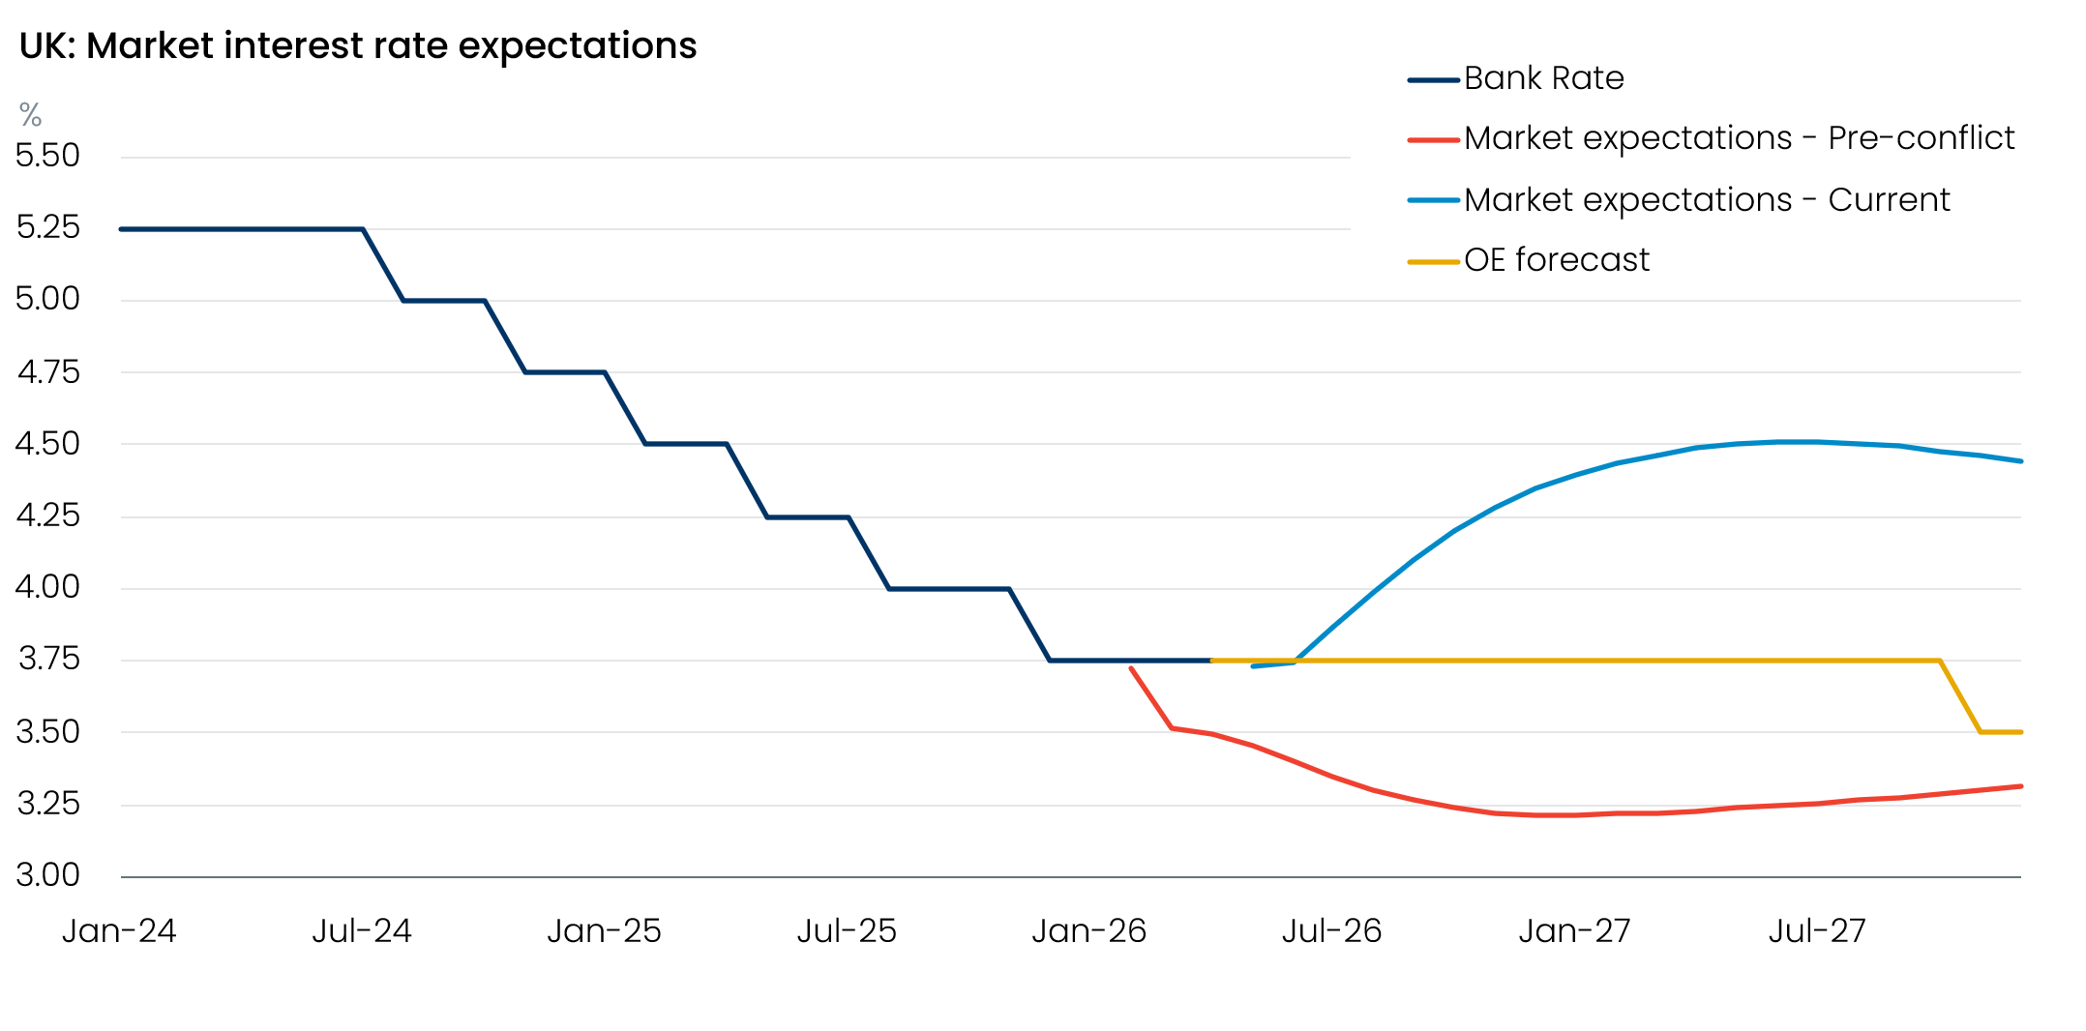
Sources: Oxford Economics, Haver Analytics
The inflation outlook has changed substantially because of the conflict in the Middle East, and the experience of the past few years has left the impression that the UK is particularly vulnerable to energy shocks. The 1yr-1yr forward rate for the UK has risen by 110bps since the conflict began, but only by 70bp-75bp for the US and Eurozone.
Our baseline assumption is the US and Iran will reach an agreement that allows traffic flows to resume in the Strait of Hormuz, allowing oil and gas prices to fall back. If this scenario plays out then we expect the Bank of England will keep policy unchanged, rather than hike. Most Monetary Policy Committee members have pointed to differences between the current situation and 2022-2023, during the last energy price shock.
The labour market is much looser now, suggesting that workers will struggle to secure higher pay rises to mitigate the impact of higher inflation, while firms have less pricing power. The previous energy shock also occurred against a backdrop of very expansionary monetary policy, as well as generous fiscal support to cushion the impact of higher energy bills on households and firms. And although some evidence suggests that inflation expectations have risen, the increase has been much smaller than in 2022-2023.
So as markets respond to no rate hikes, yields should gradually be pulled lower. However, a no-hike scenario is far from assured – as we argued in our reaction to the April MPC meeting, the risks are skewed towards modest tightening in the summer.

Domestic politics could push up term premia
So far, the rise in UK yields has largely been a story of monetary policy expectations, but fiscal concerns are now coming to the fore. We’ve pointed out previously that local elections this month could be a trigger to an increase in political uncertainty. Labour fared badly, losing 1,496 council seats. At 17% of the vote, their projected national vote share would put them joint-third with the Conservatives, behind Reform UK and the Green party (Chart 4). Though it’s common for governing parties to lose seats in local elections, the scale of Labour’s losses is extreme.
Chart 4: The political map has fragmented, with Reform and the Greens now leading
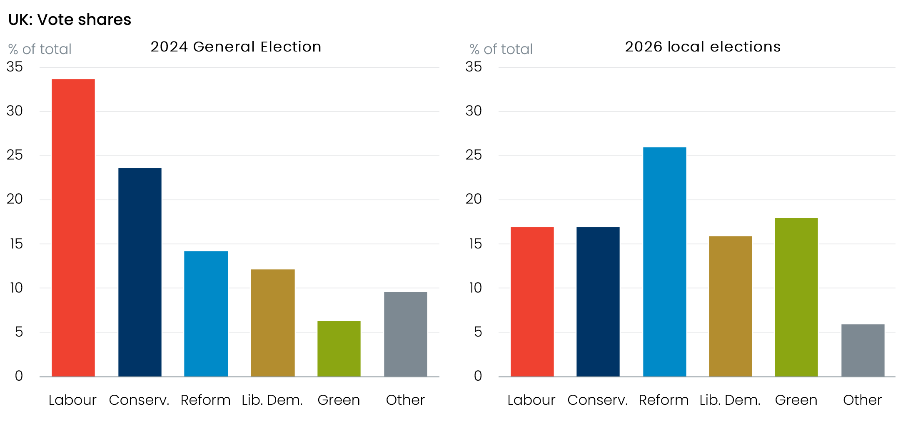
Source: BBC
Meanwhile, Prime Minister Keir Starmer and many of his senior team have low approval ratings. The local election results show that this is being reflected at the ballot box, ratcheting up the pressure on Starmer to stand down.
In his comments since the elections, Starmer has suggested he will fight on. Although he has not indicated any major policy shifts that could bring about a change of fortunes, to consolidate his position he will likely have to try something new to boost his popularity. This could include a near-term fiscal loosening to try to cushion the blow of higher energy prices and reduce the risk of recession. But such a move would risk denting his credibility with markets that have so far given him the benefit of the doubt, despite Labour’s unconvincing fiscal plans.
We think the chances that Starmer will be forced to stand down are high, though his departure could take time. So far, more than 70 Labour MPs have called for the prime minister to quit, just short of the 81 needed to force a leadership contest. Some of the hesitation is likely because potential successors such as Angela Rayner and Andy Burnham both have incentives to delay the start of a leadership contest. It may also reflect a desire to wait for a resolution to the Middle East conflict.
The Prime Minister has suggested he would stand in any leadership contest, but it seems very unlikely that he would win. Assuming Starmer is unable to staunch the haemorrhaging, we think he might agree to a compromise timetable for his departure later in the year, giving the other leading candidates time to resolve their own issues. This would probably result in a persisting uncertainty premium on gilts.
As we explained in our recent note, all of the potential candidates to lead the Labour Party would likely propose a change in economic policy priorities. However, the UK’s parlous fiscal situation means markets are likely to be wary of those advocating a more costly left-wing economic approach.
Earlier this year, we identified a series of other factors that will put upward pressure on yields at the longer end. Structural changes in the pension sector point to weaker gilt demand from what has been a large and relatively price-inelastic purchaser, particularly at the long end. At the same time, the global supply of highly-rated government bonds is increasing sharply.
So even though we think market expectations for Bank Rate will gradually drop back, this will likely be offset by the term premium rising further and remaining high (Chart 5). As a result, we expect the 10-year gilt yield to remain close to 5% for the remainder of this year.
Chart 5: UK term premium is likely to rise further in the short-term and then stay elevated
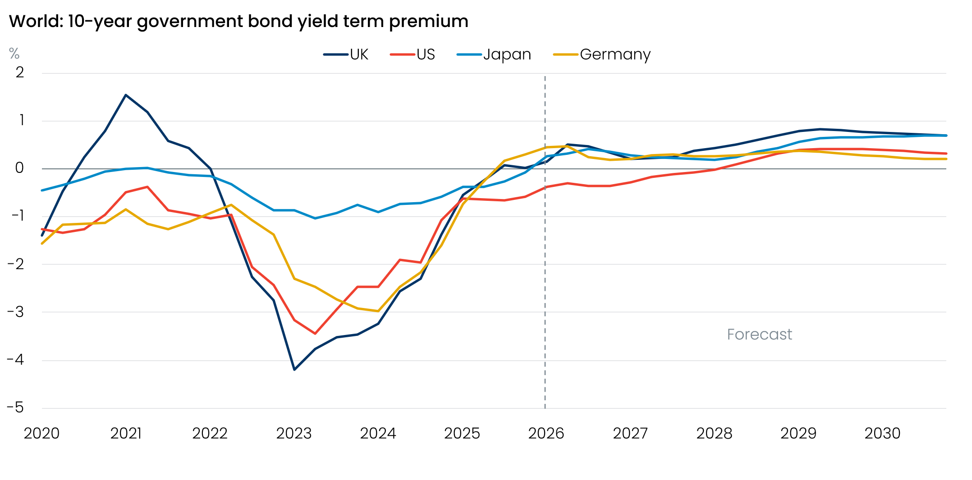
Sources: Oxford Economics, Haver Analytics

Higher bond yields on their own won’t force a change to fiscal plans
In recent years, rising gilt yields have had a direct impact on fiscal policy because successive governments have had little headroom. That has meant the Office for Budget Responsibility’s judgement about whether the government was complying with the UK’s fiscal rules has been very vulnerable to changes in debt servicing costs.
That’s not likely to be the case now. This is partly because the Chancellor took the sensible decision to significantly increase her margin for error at the 2025 Budget. It’s also because the window used for financial market pricing in the OBR’s most recent forecast coincided with a period of relatively high yields and expectations for Bank Rate. We calculate that if current market pricing holds until the autumn Budget, the government’s headroom would be cut by about £6bn to £17.6bn. However, absent other revisions, we think it unlikely the Chancellor will opt to tighten policy in response.

But tighter financial conditions will weigh on an already-weak growth outlook
The implications for the rest of the economy are substantial. In its recent Monetary Policy Report, the MPC noted that the tightening in financial conditions since the start of the Middle East conflict would provide some insurance against the risk of second-round effects. But this insurance comes at the cost of a weaker growth outlook.
Since the start of the conflict, we’ve raised our forecast for Bank Rate and the 10-year gilt yield by an average of 45bps-50bps a quarter in 2026 and 2027. Simulations using our Global Economic Model suggest increases in Bank Rate and gilt yields of this scale will reduce the level of GDP at the end of next year by 0.2ppts.
Two sectors – corporates and housing – are particularly vulnerable to these effects. Most corporate debt is floating rate or fixed at short maturities, so the passthrough of tighter financial conditions to firms’ borrowing costs will be rapid. Corporate profitability has already fallen to previous post-global financial crisis lows, and the Middle East conflict will push up input costs for many firms, and still-weak demand will continue to limit their ability to pass on these costs increases. Higher borrowing costs will add to the squeeze. Our model scenario suggests that the tightening in financial conditions alone will cut business investment by 0.5ppts by the end of 2027.
For the housing market, BoE data suggests that quoted interest rates in April on average two- and five-year fixed-rate 75% loan-to-value mortgages were 117bps and 99bps above their February levels. At the start of 2026, our New Home Buyer Affordability Index, which is based on the affordability of mortgage payments, suggested that prices were just 3% overvalued – less stretched than at any time since Q1 2022. But the valuation gap has now risen to 12%.
Some of the increase in quoted mortgage rates reflects a widening in lending spreads, which we see as a reflection of banks’ reduced appetite for lending at a time when market pricing is very volatile. This is consistent with a sharp drop in the number of mortgage products available. We think lending conditions will start to improve, leading to a normalisation in spreads. But higher funding costs are likely to mean that mortgage rates settle some way above the levels seen before the Iran conflict (Chart 6).
Chart 6: Mortgage rates have risen by 100bps in two months and are likely to remain elevated
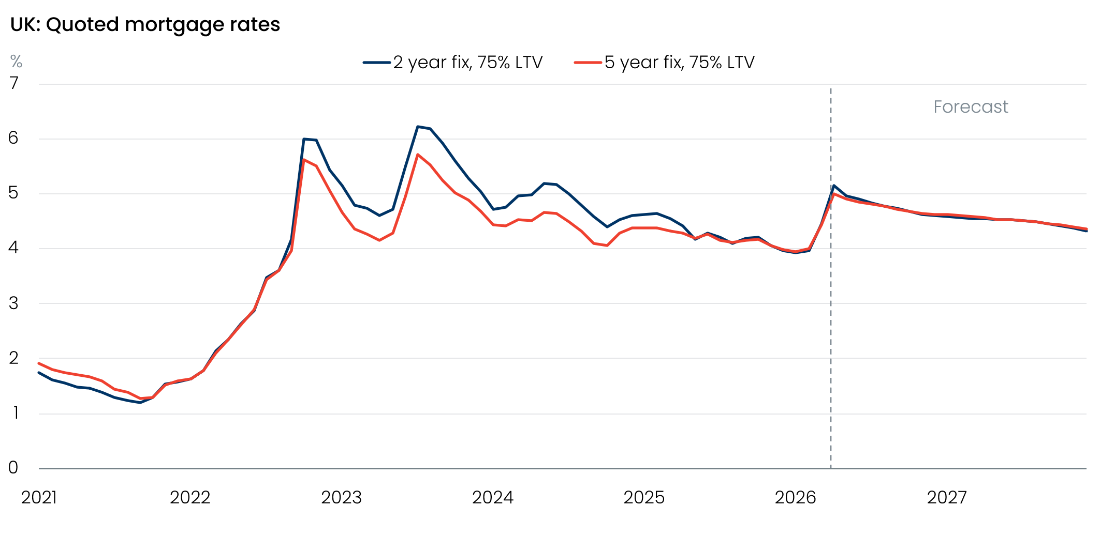
Sources: Oxford Economics, Haver Analytics
Reduced affordability for new buyers and those trading up will subdue mortgage activity and cool house price growth. It also adds to the challenges for those mortgagors yet to refinance cheap fixes taken out before mortgage rates began to climb in 2022. We estimate that borrowers who took out a five-year fix in 2021 face an increase in their mortgage rate of more than 300bps when they refinance this year.

